ANTIBACTERIAL ACTIVITY OF BRANDED HONEY PREPARATIONS
(Sold in THIKA town) ON SELECTED PRIORITY BACTERIAL STRAINS

BY

PRINCE KAMANZI
BPHARM/2016/56566

A RESEARCH PROJECT SUBMITTED IN PARTIAL FULFILLMENT FOR THE AWARD OF DEGREE IN BACHELOR OF PHARMACY OF MOUNT KENYA UNIVERSITY.

MOUNT KENYA UNIVERSITY
COLLEGE OF HEALTH SCIENCES
DEPARTMENT OF PHARMACOGNOSY AND PHARMACEUTICS

SEPTEMBER 2021

DECLARATION
Declaration by the Student
I hereby declare that the project entitled ‘‘ANTIBACTERIAL ACTIVITY OF BRANDED HONEY PREPARATION (sold in THIKA town) ON SELECTED PRIORITY BACTERIAL STRAINS’’ in partial fulfillment of the requirement for the award of the bachelor of pharmacy degree, is a work project carried out by me under the guidance of Dr. JAMES MEROKA. I further declare that the work reported in this project has not been submitted and will not be submitted either in part or in full, for the award of any other degree in this institute or any other institute or university.
.
Sign ____________________ Date _____________

PRINCE KAMANZI
BPHARM/2016/56566
Declaration by the supervisor
This research project has been submitted with my approval as The Mount Kenya University Supervisor.

Sign ____________________ Date _____________

DR. JAMES MEROKA

DEDICATION
I wholeheartedly dedicate this project to my beloved parents HATANGIMBABAZI Eugene and MUKAKAMANZI Christine, who have been my source of inspiration, who have encouraged me all the way and their encouragement has made sure that I give it all it takes to finish that which I have started.
To my brother, sisters, relatives, friends and classmates for being there for me through the bachelor program.
All of you have been my best cheerleader.
Above all, I dedicate this project to the Almighty God. Finishing this manuscript is a great opportunity to express my wholehearted thanks and many praises to him.

ACKNOWLEDGEMENT
I would like to express my special thanks of gratitude to my supervisor Dr. JAMES MEROKA and my laboratory technicians Mr. Elias Mandela, who gave me the golden opportunity to do this wonderful project. Who also helped me in completing my project; I come to know about so many new things, I am really thankful to them. Secondly, I would also like to thank my parents, relatives and friends who helped a lot in finalizing this project within the limited time frame, Thank you.
I would also like to extent my gratitude to Mount Kenya University for providing me with all the facility that was required.
Above all to the Great Almighty, the author of knowledge and wisdom for his countless Love.
THANK YOU.

TABLE OF CONTENT.
DECLARATION ii
DEDICATION iii
ACKNOWLEDGEMENT iv
LIST OF FIGURES vii
LIST OF ABBREVIATIONS viii
ABSTRACT ix
CHAPTER ONE. INTRODUCTION 1
1.1. Background of the Study 1
1.2. Problem statement 2
1.3 Objective of the study 3
1.3.1 General Objective 3
1.3.2 Specific Objectives 4
CHAPTER TWO: LITERATURE REVIEW 5
2.1 Introduction 5
2.2 Branded and Unbranded Content. 5
2.3 Honey as Food. 5
2.4 Composition of Honey 5
2.5 Physical Properties of Natural Honey 6
2.6 Possible Mechanism of Antimicrobial Activity of Honey 6
2.7 Antibiotics 6
2.7.1 Classification of Antibiotics 6
2.9 Acinetobacter Baumannii. 10
2.10 Salmonella enteritidis. 10
2.11 Bacillus subtillis 11
CHAPTER THREE: METHODOLOGY 12
3.1 Study Design. 12
3.2 Test Microorganisms. 12
3.3 Materials, Solvents and Reagents. 12
3.3.1 Materials and Solvents 12
3.3.2 Apparatus and Equipment. 12
3.4 Antimicrobial Test. 12
3.4.1 Preparation of the Muller Hilton agar. 12
3.4.2 Preparation of Microorganism Inoculants. 13
3.4.3 Preparation of Susceptibility Test Discs. 13
3.4.4 The Agar Disc Diffusion Method. 13
3.4.5 Test Micro-Organisms. 13
3.5 Antibacterial Activity of branded honey by Disc Diffusion Method. 13
CHAPTER FOUR: RESULTS AND DISCUSSIONS 15
4.1. Antimicrobial activity of branded honey Samples against gram-negative and gram-positive bacteria. 15
4.1.1 Antimicrobial activity of branded honey against gram-negative (Acinetobacter baumannii) 15
4.1.2. Antimicrobial activity of branded honey against gram-negative (Salmonella enteritidis) 19
4.2. Antimicrobial activity of branded honey against gram-negative (Bacillus subtilis) 22
4.3 Discussion of the Results 26
CHAPTER FIVE: CONCLUSIONS AND RECOMMENDATION 27
5.1 Conclusion 27
5.2 Recommendations 27
REFERENCES 28
APPENDIX 30

LIST OF FIGURES
Figure 1: Acinetobacter Baumannii 10
Figure 2: Salmonella enteritidis. 11
Figure 3: Bacillus subtillis 11
Figure 4: Three honey sample and their dilutions 30
Figure 5: Zones of inhibition of branded honey samples against gram positive bacteria. 31
Figure 6: Zones of inhibition of branded honey samples against gram negative bacteria. 31

LIST OF ABBREVIATIONS

Abbreviation | Meaning
S. enteritidis | Salmonella enteritidis
B.subtillis | Bacillus subtillis
AMR | Antimicrobial resistance
NS | No significant difference
A.baumannii | Acinetobacter baumannii
BC | Before Christ
ASALs | The Arid and Semi-Arid Lands
KTB | Kenya Top Bar
SEM | Standard Error of Mean
DMSO | Dimethyl sulfoxide
EtOH | Ethanol

ABSTRACT
Honey is defined as a sweet viscous liquid produced by honey bees from the nectar of plants. Its antimicrobial properties have been used back in years as food and for medicinal purpose and it is still used nowadays. This study was carried out to determine antimicrobial activity of branded honey samples sold in Thika town. The potential of branded honey to be used as antibacterial agents was established by assessing its activity against three different bacterial strains which are gram positive Bacillus subtilis, gram negative Acinetobacter baumannii and Salmonella enteritidis. The antibacterial laboratory tests were carried out using disc diffusion method using culture media prepared from Mueller- Hinton agar. Antibacterial activity was statistically presented as the mean ± Standard error of the mean of zones of inhibition. Antibiotic resistance of bacteria has been a global challenge over many years which is the burden of world economy in both underdeveloped and developed countries. This initiated the need for rescue by using natural products resources like plants, herbs, animal, and their products which is a safer, better, accessible and effective way to overcome the AMR problem among different bacterial strains. In this study the in vitro antibacterial activity of branded honey was tested against Acinetobacter baumannii, Bacillus subtillis, and Salmonella enteritidis. This involved a process of aseptically laying the cylindrical paper disc (5mm) on to the already inoculated Muller Hilton agar with specific microorganism and then directly pipetting 4 dilutions of the different concentrations of the branded honey preparation on to the disc in 100, 75, 50, 25 proportions. The disc was allowed to dry prior to upside down incubation at 37ºc for 24 hours after which the inhibition zones were recorded, all branded honey samples showed mild antibacterial activity against both gram-negative and gram-positive bacteria and the antibacterial activity of the branded honey samples.

CHAPTER ONE. INTRODUCTION

1.1. Background of the Study
Honey is defined as “a sweet, sticky yellowish-brown fluid made by bees and other insects from nectar collected from flowers, it generally obtained from honey combs, built by worker bees which transform nectar from flowers into honey by a process of regurgitation and evaporation, they then store it as a primary food source in waxy honey combs inside the beehive. (Bhuvaneswari et al. 2014)
These honey bees are also cultured commercially for their ability to produce honey that is sold in market as branded products.
The use of honey as a drug for the treatment of disease dates back to 2100-2000 BC. For instance, pale honey was described by Aristotle (384-322 BC) as being ‘‘good for sore eyes and wounds, the antimicrobial properties of honey have been well documented, and honey has been used from ancient times as a method of accelerating wound healing.(Almasaudi et al. 2017)
Among features that make this product effective against micro-organisms, we can quote high osmotic pressure by low water activity (average 17.2%); low pH because of the presence of organic acids, mainly gluconic acid (average 3.9); the presence of hydrogen peroxide generated by action of enzyme glucose oxidase; low protein content; low redox potential due to the presence of reducing sugars; and chemical agents present as lysozyme, phenolic acids, pinocembrin, terpenes, benzyl alcohol, and volatile substances.(Silva and Eller 2017)
Antibacterial activity of honey was ﬁrst recognized in 1892; however, it has a limited use in modern medicine due to lack of scientiﬁc support, it contains 15% to 20% water and 80% to 85% sugar. (Mama, Teshome, and Detamo 2019)
Honey is made up of starch: 1%, trisaccharides: 2%, maltose: 7%, water: 17%, glucose: 31% and fructose: 38%, the quality of honey produced in recent years have decreased, this might be due to infection of bees by microorganisms, resulting in the death of bees and also the quest for wealth has led to the use of antibiotics to increase the yield of honey production, others add sweeteners to increase the volume of honey, thus reducing the quality and its antimicrobial.(Agbagwa, Rani, and Halami 2017)
Branded honey is processed and well packaged, they usually have a brand. Some branded honey might have been analyzed by being exposed to high level of heat; pollens are often filtered off and pasteurized thus making the product appealing to the eyes. Most of them lack some basic health benefits and the origin cannot be detected, the extensive use of antibiotics in beekeeping has led to an accumulation of antibiotic residues in honey, thereby leading to decreased quality and difficulty in marketing.(Agbagwa, Rani, and Halami 2017)
Antibiotics are used in beekeeping as growth promoters and to treat diseases. Research has shown the presence of antibiotics residue in honey ,for example oxytetracycline and chloramphenicol residues have been found to be above the regulatory standards in honey, other antibiotics such as erythromycin, lincomycin, monensin, streptomycin and enroﬂoxacin have also been detected in honey.(Agbagwa, Rani, and Halami 2017)
ASALs have plentiful flora that is important for bee feeding. Only about 20% of annual honey production potential (25,000 metric tons) is achieved in Kenya, leaving the full potential of 100,000 metric tons unrealized. Kenya is the third important producer of honey in Africa after Ethiopia and Tanzania. The apiculture policy has broadly promoted a modern bee keeping industry to provide additional income for rural households. Modern bee keeping is an important enterprise in the livestock sub-sector. The traditional log hives contribute 80% of the honey produced while modern hives such as the Kenya Top Bar (KTB), Langstroth hives and mixed modern-traditional hives produce the rest 20%.
Several studies have shown the presence of substances with antimicrobial activity such as hydrogen peroxide and several phytochemical compounds such as flavonoids, phenols, organic acids like cinnamic acid, methyl syringate, and methylglyoxal, which limit the number of microorganisms present in honey and allow only those that manage to survive to remain viable.

1.2. Problem statement
Honey is a product with low water activity because of the great amount of sugars (fructose and glucose), and also it has antimicrobial compounds derived from flowers or because of its transformation process in the beehive.
Honey has had a valued place in traditional medicine for centuries. It was used to overcome liver, cardiovascular and gastrointestinal problems and for treatment of some types of infectious disease. Particularly, good results were achieved in the case of application of this product for therapy of infected, difficult to heal wounds.(Szweda 2017)
Antimicrobial drugs are the greatest contribution of the 20th century to therapeutics. Their advent changed the outlook of the physician about the power drugs can have on diseases.
They are one of the few drugs which can cure, and not just palliate disease. Their importance is magnified in the developing countries, where infective diseases predominate. As a class, they are one of the most frequently used as well as misused drugs.(Mann 1964)
Despite the enormous advance in health care made during the last half-century, infectious diseases still account for 25% of mortality worldwide and 45% in low-income countries, among these, pathogenic and antibiotic-resistant bacteria pose a very serious threat to public health which makes them the main cause of mortality and morbidity in hospitals and community.(Mama, Teshome, and Detamo 2019)
Antimicrobial agents are critically important in reducing the global burden of infectious diseases occurrence of drug-resistant microorganisms diminished the development of antibiotics, and few pharmaceutical companies remain active in this area, posing big challenge in this world, hence, the failure of these antibiotics has resulted for a man to search for more eﬀective sources of natural products from plants and others. antibacterial activity of honey was ﬁrst recognized in 1892; however, it has a limited use in modern medicine due to lack of scientiﬁc support,.(Mama, Teshome, and Detamo 2019) . The antimicrobial activity of honey is highly complex and still remains not fully recognized, to date, it has been established that several components of this product play a crucial role for its antimicrobial properties(Picco et al. 2016)
Hence, the purpose of this study was to evaluate antibacterial activity of branded honey against selected bacteria strains. Bacillus subtillis, Acinetobacter baumanni. Salmonella enteritidis.

1.3 Objective of the study

1.3.1 General Objective
The main objective of this study was to investigate the antibacterial activity of branded honey sold in Thika town.

1.3.2 Specific Objectives
Specific objectives are set as follows:
To evaluate antibacterial activity of branded honey against selected bacterial strains.
The selected bacteria strains are:
1. GRAM POSITIVE
- Bacillus subtillis.
2. GRAM NEAGATIVE
- Salmonella enteritidis.
- Acinetobacter baumnii.

CHAPTER TWO: LITERATURE REVIEW

2.1 Introduction
According to Mugenda O. and Mugenda A. (2003) « Literature review involves the systematic identification, location and analysis of documents containing information related to the research problem being investigated. » (p. 29) Clearly, Mutai (2000: 90-96) discussed the term ‘literature review’ and viewed that “It implies a review of empirical studies, historical records, governments reports, newspaper accounts, and so forth.”
In that respect, the purpose of this chapter is to assess the microbiological quality of branded and unbranded honey sold in Thika town.

2.2 Branded and Unbranded Content.
Branding is a tool used by producers to increase consumer awareness and loyalty.
The goal of such marketing, strategies is to convince consumers that the brand name is a substitute for expected benefits.
Branded content is usually clearly about a brand and appears to either represent the brand or portrays the brand as the subject of the content. It's content that has your brand "written all over it" even if you didn't create the content.

2.3 Honey as Food.
Honey is most commonly consumed in its unpreserved state, i.e. liquid, crystallized or in the comb. In these forms, it is taken as medicine, eaten as food or incorporated as an ingredient in various food recipes. In confectionery production, honey is still included in many traditional products, which are consumed locally in considerable quantities and also exported. In gelatinous or gum product, honey can be used as flavoring agent. In industrial sector, some honey milk products exist such as pasteurized and homogenized sweetened with honey for long time storage e.g. yoghourt with honey.(Olaitan and Adeleke n.d.)

2.4 Composition of Honey
Honey is a sweet viscous liquid produced by honey bee, it is made up of starch: 1%, trisaccharide: 2%, maltose: 7%, water: 17%, glucose: 31% and fructose: 38%.(Agbagwa, Rani, and Halami 2017)
Several studies have investigated the antimicrobial properties of honey against bacteria, honey has been reported to containing about 200 substances, a complex mixture of sugars with small amounts of other constituents, such as minerals, proteins, vitamins, aroma compounds, organic acids, enzymes, phenolic acids, ﬂavonoids, pigments, waxes, pollen grains and other phytochemicals.(Fernandes et al. 2020)

2.5 Physical Properties of Natural Honey
Honey has several important qualities in addition to composition and taste, freshly extracted honey is a viscous liquid, its viscosity depends on large variety of substances and therefore varies with its composition and particularly with its water Content, hygroscopicity of honey is another property that describes the ability of honey to absorb and hold moisture from environment, normal honey with water content of 18.8% or less will absorb moisture from air of a relative humidity of above 60%, the surface tension of honey varies with the origin of the honey and is probably due to colloidal substances, together with high viscosity, it is responsible for the foaming characteristics of honey.(Eteraf-oskouei and Najafi n.d.)

2.6 Possible Mechanism of Antimicrobial Activity of Honey
Mechanism of antimicrobial activity of honey which attack the bacteria’s cell wall or inhibit intracellular metabolic pathways, honey is hygroscopic, meaning it draws moisture out of the environment and thus dehydrates bacteria, its sugar content is also high enough to hinder the growth of microbes, but the sugar content alone is not the sole reason for honey’s antibacterial properties because when honey is diluted with water, reducing its high sugar content, it still inhibits the growth of many different bacterial species that cause wound infections.(Simon et al. 2009)

2.7 Antibiotics
These are substances produced by microorganisms, which selectively suppress the growth of or kill other microorganisms at very low concentrations. This definition excludes other natural substances which also inhibit microorganisms but are produced by higher forms (e.g. antibodies) or even those produced by microbes but are needed in high concentrations (ethanol, lactic acid, H2O). (Mann 1964)

2.7.1 Classification of Antibiotics
Antimicrobial drugs can be classified in many ways:
Chemical structure

CLASS | EXAMPLES
1. Sulfonamides and related drugs | Sulfa-diazine, Sulfones-Dapsone (DDS), Paraaminosalicylic acid (PAS).
2. Diaminopyrimidines | Trimethoprim,Pyrimethamine.
3. Quinolones | Nalidixic Acid, Norfloxacin,  Ciprofloxacin, Prulifloxacin, etc.
4. Lactam antibiotics | Penicillin, Cephalosporins, Monobactams, Carbapenems.
5. Tetracyclines | Oxytetracycline, Doxycycline, etc.
6. Nitrobenzene derivative | Chloramphenicol.
7. Aminoglycosides | Streptomycin, Gentamicin, Amikacin  Neomycin, etc.
8. Macrolide antibiotics | Erythromycin, Clarithromycin, Azithromycin, etc.
9. Lincosamide antibiotics | Lincomycin, Clindamycin.
10. Glycopeptide | Vancomycin, Teicoplanin.
11. Oxazolidinone | Linezolid.
12. Polypeptide antibiotics | Polymyxin-B, Colistin, Bacitracin, Tyrothricin.
13. Nitrofuran derivatives | Nitrofurantoin, Furazolidone.
14. Nitroimidazoles | Metronidazole, Tinidazole, etc.
15. Nicotinic acid derivatives | Isoniazid, Pyrazinamide, Ethionamide.
16. Polyene antibiotics  . | Nystatin, Amphotericin-B, Hamycin.
17. Azole derivatives | Miconazole, Clotrimazole, Ketoconazole, Fluconazole.
18. Others | Rifampin, Spectinomycin, Cycloserine, Viomycin, Ethambutol, Thioacetazone, Clofazimine, Griseofulvin.

Mechanism of action
CLASS | EXAMPLES
1. Inhibit cell wall synthesis | Penicillins, Cephalosporins, Cycloserine, Vancomycin, Bacitracin.
2. Cause leakage from cell membranes | Polypeptides-Polymyxins, Colistin,  Bacitracin, Polyenes-Amphotericin B,  Nystatin, Hamycin.
3. Inhibit protein synthesis | Tetracyclines, Chloramphenicol, Erythromycin, Clindamycin, Linezolid.
4. Cause misreading of m-RNA code and affect permeability | Aminoglycosides-Streptomycin, Gentamicin, etc.
5. Inhibit DNA gyrase | Fluoroquinolones-Ciprofloxacin and others.
6. Interfere with DNA function | Rifampin.
7. Interfere with DNA synthesis | Acyclovir, Zidovudine.
8. Interfere with intermediary metabolism: | Sulfonamides, Sulfones, PAS, Trimethoprim,  Pyrimethamine, Metronidazole.

2.9 Acinetobacter Baumannii.
The history of the genus Acinetobacter dates back to the early 20th century, in 1911, when Beijerinck a Dutch microbiologist, described an organism named Micrococcus calcoaceticus that was isolated from soil by enrichment in a calcium acetate-containing minimal medium , over the following The genus Acinetobacter is currently defined as gram-negative, strictly aerobic, nonfermenting, non-fastidious, nonmotile, catalase-positive, oxidase-negative bacteria with a DNA G+C content of 39% to 47%.(Peleg, Seifert, and Paterson 2008)
In 2017, carbapenem-resistant Acinetobacter caused an estimated 8,500 infections in hospitalized patients and 700 estimated deaths in the United States, some research has shown that it can cause infections in the blood, urinary tract, and lungs (pneumonia), or in wounds in other parts of the body, It can also “colonize” or live in a patient without causing infections or symptoms, especially in respiratory secretions (sputum) or open wounds.(Acinetobacter in Healthcare Settings _ HAI _ CDC n.d.)

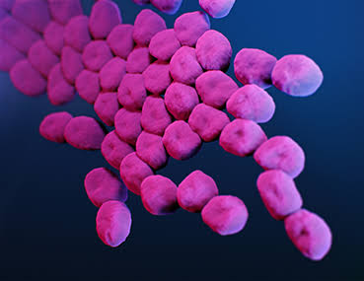
Figure 1: Acinetobacter Baumannii

2.10 Salmonella enteritidis.
Salmonella is a Gram-negative, facultative anaerobic bacteria, belonging to the family of Enterobacteriaceae .(Afshari et al. 2018)
Salmonella Enteritidis (SE) is the predominant cause of the food-borne salmonellosis in humans.(Genetic Basis of Salmonella Enteritidis Pathogenesis in Chickens - ScienceDirect n.d.)
A bacterium, Salmonella enteritidis, can be inside perfectly normal-appearing eggs, and if the eggs are eaten raw or undercooked, the bacterium can cause illness. During the 1980s, illness related to contaminated eggs occurred most frequently in the northeastern United States, Consumers should be aware of the disease and learn how to minimize the chances of becoming ill, a person infected with the Salmonella enteritidis bacterium usually has fever, abdominal cramps, and diarrhea beginning 12 to 72 hours after consuming a contaminated food or beverage.(Salmonella enteritis Infection n.d.)

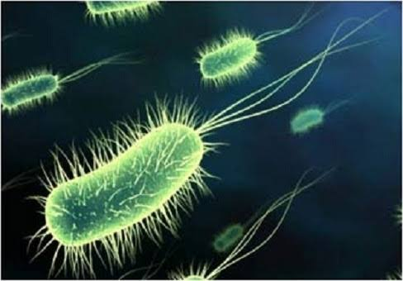
Figure 2: Salmonella enteritidis.

2.11 Bacillus subtillis
Genus Bacillus is a spore-forming bacterium that has unique properties in cell differentiation, allowing the forming of spores in stress conditions and activated in the vegetative cell, with suitable environments occurring during the life cycle acting as a trigger, their habitat is mainly in soil; thus, many species of Bacillus are associated with plants as well as rhizosphere bacteria and endophytic bacteria.(Mongkolthanaruk 2014)

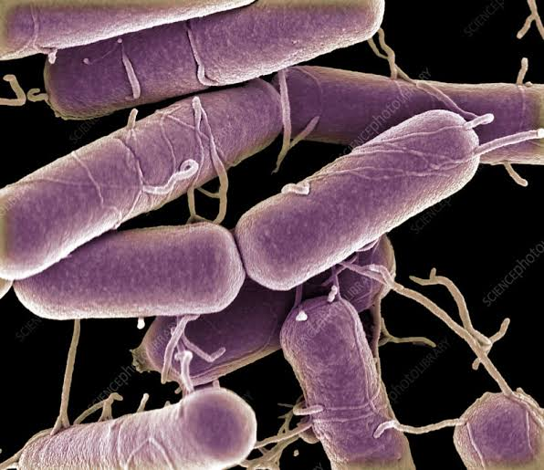
Figure 3: Bacillus subtillis

CHAPTER THREE: METHODOLOGY

3.1 Study Design.
This experiment used in vitro study to investigate the antibacterial activity of branded honey (sold in Thika town). The antibacterial activity testing was based on the following three microorganisms:
- One gram -positive bacteria: Bacillus subtilis
- Two gram-negative bacteria: Acinetobacter baumannii and salmonella enteritidis.

3.2 Test Microorganisms.
The test micro-organisms used in this study were pure cultures of Bacillus subtilis, Acinetobacter baumannii and Salmonella enteritidis.
All those microorganisms were available at the Mount Kenya university microbiology laboratory.

3.3 Materials, Solvents and Reagents.

3.3.1 Materials and Solvents
The Whatman filter paper No.1 (Whatman International Ltd, Maid stone, England), 0.1%DMSO, Ethanol, Nutrient agar (CMO007 Mueller Hinton Agar), sterile petri dishes, forceps, stick swab for inoculation, ruler, sterile straw and sterile gloves.

3.3.2 Apparatus and Equipment.
Conical flask 1L, test tubes, funnels, micropipettes.
Equipments used were Autoclave, Incubator, and Analytical balance.

3.4 Antimicrobial Test.

3.4.1 Preparation of the Muller Hilton agar.
Based on manufacturer’s instructions, Muller Hilton agar powder was measured 49.4 grams and suspended into 1300ml of distilled water, shaken and heated on a hotplate while stirring to dissolve. The media was thereafter sterilized in autoclave at 121 ⁰C and 15 bar pressure for 15 minutes. The sterile media was allowed to cool to about 45ºC and about 20 ml was dispensed on the sterile disposable plates.

3.4.2 Preparation of Microorganism Inoculants.
All the test microorganisms were first sub cultured on Muller Hilton agar to test their viability. The well isolated colonies of the respective microorganisms were suspended in distilled sterile water and the turbidity compared to that of the 0.5 Mac Faland.

3.4.3 Preparation of Susceptibility Test Discs.
The susceptibility test discs (5 mm) on to which the extracts were impregnated were prepared by punching out on a Whatman no. 1 filter paper using a paper punch. The discs were then filled into the autoclavable glass bottle and loosely capped prior to sterilization. The discs were then rendered sterile by autoclaving at 121 ⁰C and pressure of 15 bars for 15 minutes.

3.4.4 The Agar Disc Diffusion Method.
Media was solidified first then; the three microorganisms were taken and each microorganism was inoculated into its own sterile disposable plate containing the specific media. Each plate was then divided into five portions according to the concentrations prepared.
Honey sample solutions was prepared by toping up a 100 ml of distilled water to 0.1% DMSO that was used to dilute honey into 100%,75%,50%,25% concentration. Whatman filter paper discs about 6 mm in diameter, were placed on every section of the plate and saturated with respective prepared concentrations of branded honey.
The procedure for every microorganism was done on two plates for comparison and verification purpose. After inoculation, the plates were incubated in a vacuum incubator for 24hrs at 37◦C.

3.4.5 Test Micro-Organisms.
- Bacillus subtilis
- Acinetobacter baumannii
- Salmonella enteritidis

3.5 Antibacterial Activity of branded honey by Disc Diffusion Method.
The antibacterial activity of branded honey was measured by its ability to prevent the growth of the microorganisms surrounding the discs which gives a clear zone of inhibition. After incubation for 24hrs at 37ºC, the antibacterial activities of the test materials were determined by measuring the diameter of the zones of inhibition in millimeter (mm) with a transparent scale and results was recorded.

CHAPTER FOUR: RESULTS AND DISCUSSIONS

4.1. Antimicrobial activity of branded honey Samples against gram-negative and gram-positive bacteria.
The antimicrobial activity of branded honey was evaluated by using disk diffusion technique. Samples used were collected from different supermarkets and the brand were different. Our samples were diluted to obtain four different working concentrations (100%, 75%, 50% and 25%) and they were tested against the antibacterial activity testing was based on the following three microorganisms:
- One gram -positive bacteria: Bacillus subtilis.
- Two gram-negative bacteria: Acinetobacter baumannii and salmonella enteritidis.
Results obtained were presented as ‾X±SEM with different superscript letter are significantly different (one way an over followed by turkey’s post hoc test, p<0.05)
NOTE: The symbol (*) used in figures below was used to indicate the significance difference,
so, the more the difference the more we increase the numbers of asterisk (*) to symbolize it.

4.1.1 Antimicrobial activity of branded honey against gram-negative (Acinetobacter baumannii)
The results for the antimicrobial activity of branded honey against Acinetobacter baumannii was presented in table 4.1.fig.4.1, fig.4.2. The results describe the concentration dependent activity of the highest antimicrobial being reported at the highest concentration. (Table 4.1). When comparing honey sample, A, B and C for different concentration against Acinetobacter baumannii, we noted that; At a positive control (piperacillin 100mcg) there was a slightly difference between honey sample A and B hence (P<0.05; fig.4.1), but there was no significant difference between sample A and C as well as sample B and C against Acinetobacter baumannii hence (P>0.05; fig.4.1). At a 100% concentration we noted that there was significant difference between the three honey samples against Acinetobacter baumannii hence (P>0.05; fig.4.1).

At a 75% concentration we noted a significance difference between sample A and B, and also between sample A and C hence (P<0.05; fig.4.1), there was also no significant difference between sample B and C, on the other hand we have noticed that there was no significant difference at 50%, 25% and the negative control (0.1% DMSO). The studied antimicrobial activity for sample A showed no significant difference between negative control (0.1% DMSO) and 75%, 50% and 25%, there was also no significant difference between 25% and 50%, 50% and 75% against Acinetobacter baumannii(P>0.05; fig.4.2), on the other hand positive control had shown significant difference for both 100%, 75%, 50%, 25% and the negative control, there was also a significance difference between 100% and both 75%, 50%, 25% and the negative control (0.1% DMSO) (P<0.05; fig.4.2), and the same happened to both sample B and C.

Table 4.1 Antimicrobial activity of branded honey against Acinetobacter baumannii
Concentration/sample | Mean ±SEM
Concentration/sample | Sample A | Sample B | Sample C
Positive control(piperacillin100mcg) | 24.500±0.500 | 25.500±0.500 | 24.750±0.250
100% | 9.500±0.500 | 8.000±0.000 | 10.500±0.500
75% | 7.000±0.000 | 6.000±0.000 | 6.000±0.000
50% | 6.000±0.000 | 6.000±0.000 | 6.000±0.000
25% | 6.000±0.000 | 6.000±0.000 | 6.000±0.000
Negative control (0.1%) | 6.000±0.000 | 6.000±0.000 | 6.000±0.000

Fig 4.1

Fig 4.2

4.1.2. Antimicrobial activity of branded honey against gram-negative (Salmonella enteritidis)
The results for the antimicrobial activity of branded honey against Salmonella enteritidis are presented in table 4.2.fig.4.3, fig.4.4. The results describe the concentration dependent activity where the highest antimicrobial being reported at a highest concentration. (Table 4.2). when comparing branded honey sample, A, B and C for different concentration against Salmonella enteritidis, we noted that here was no significant difference for both sample A, B and C across 1005, 75%, 50%,25% as well as positive control (piperacillin 100mcg) and the negative control (0.1% DMSO) against Salmonella enteritidis hence (P>0.05; fig.4.3). The studied antimicrobial activity for sample A showed no significant difference between negative control and 25%, 50% and also between 50% and 75% against Salmonella enteritidis (P>0.05; fig.4.4), but there was a high difference between the positive control and both 100%, 75%, 50%, 25% and the negative control, a 100% concentration also showed a significant difference when compared to other concentration, there was also a significant difference between 75% and both 25% and the negative control (0.1% DMSO) (P<0.05; fig.4.4)

Table 4.2 Antimicrobial activity of branded honey against Salmonella enteritidis
Concentration | Mean SEM
Concentration | Sample A | Sample B | Sample C
Positive control(piperacillin100mcg) | 25.500±0.500 | 24.500±0.500 | 25.000±0.000
100% | 11.500±0.500 | 11.500±0.500 | 11.500±0.500
75% | 9.500±0.500 | 9.500±0.500 | 9.500±0.500
50% | 8.500±0.500 | 8.000±0.000 | 8.000±0.000
25% | 6.000±0.000 | 6.000±0.000 | 6.000±0.000
Negative control (0.1%) | 6.000±0.000 | 6.000±0.000 | 6.000±0.000

Fig 4.3
Fig 4.4

4.2. Antimicrobial activity of branded honey against gram-negative (Bacillus subtilis)
The results for the antimicrobial activity of branded honey against Salmonella enteritidis are presented in table 4.3.fig.4.5, fig.4.6. The results describe the concentration dependent activity where the highest antimicrobial being reported at a highest concentration. (Table 4.3). When comparing honey sample, A, B and C for different concentration against Bacillus subtilis we noted that; At a positive control (Amoxicillin 30mcg) there was a small difference between sample A and B hence (P<0.05) but there was no significant difference between sample A and C and sample B and C hence (P>0.05; fig.4.5). At a 100% there was significant difference between both samples where sample A and C showed a high difference while both sample A and B, B and C showed a small (P<0.05; fig.4.5). At a 75% there was also small difference between both samples A and B and sample B and C. On the other hand, we have noticed that there was no significant difference at 50%, 25% and the negative control (0.1% DMSO) as well (P>0.05; fig.4.5). As shown on a fig.4.6, negative control shows the lowest antimicrobial activity as compared to the other concentrations and positive control. The studied antimicrobial activity for sample A showed no significant difference between negative control and both 25%, 50%, 75%, there was also no significant difference between 25% and 50%, 50% and 75%, 25% and 75% against Bacillus subtilis (P>0.05; fig.4.6). On the other hand positive control showed significant difference for both 100%, 75%, 50%, 25% and negative control against Bacillus subtilis (P<0.05; fig.4.6) and the same happened to both sample C, but on sample B , the studied antimicrobial activity showed no significant difference between negative control and both 25% and 50%, there was also no significant difference between 25% and 50% (P>0.05; fig.4.6), on the other hand positive control showed significant difference for both 100%, 75%, 50%, 25% and the negative control, there was also significant difference between 100% and both 75%, 50%, 25% and the negative control, another significant difference was seen between 70% and both 50%, 25% and the negative control against Bacillus subtilis (P<0.05; fig.4.6)

Table 4.3. Antimicrobial activity of branded honey against Bacillus subtilis
Concentration | Mean SEM
Concentration | Sample A | Sample B | Sample C
Positive control(piperacillin100mcg) | 14.500±0.500 | 13.500±0.500 | 14.000±0.000
100% | 8.000±0.000 | 9.000±0.000 | 10.000±0.000
75% | 6.000±0.000 | 7.000±0.000 | 6.000±0.000
50% | 6.000±0.000 | 6.000±0.000 | 6.000±0.000
25% | 6.000±0.000 | 6.000±0.000 | 6.000±0.000
Negative control (0.1%) | 6.000±0.000 | 6.000±0.000 | 6.000±0.000

Fig 4.5

Fig 4.6

4.3 Discussion of the Results
The use of honey as a drug for the treatment of disease dates back to 2100-2000 BC. For instance, pale honey was described by Aristotle (384-322 BC) as being ‘‘good for sore eyes and wounds, the antimicrobial properties of honey have been well documented, and honey has been used from ancient times as a method of accelerating wound healing.(Almasaudi et al. 2017)
Antibacterial studies of branded honey revealed that the activity of the honey samples was obtained decreasingly as concentration was being decreased. The Agar disk diffusion Technique showed the activity of branded honey towards the three microorganisms. There was clear zone of inhibition observed around the paper discs for Amoxicillin 30 mcg and Piperacillin 100 mcg were used as positive control while the negative controls did not show any zones of inhibition. The three honey samples have shown a decreasing antibacterial activity as the concentration decreases at a different dilution. The antimicrobial activity in honey are due to the presence of high sugar content that inhibit the growth of micro-organisms, the sugar content is high enough to hinder the growth of microbes, but the sugar content alone is not the sole reason for honey’s antibacterial properties because when honey is diluted with water, reducing its high sugar content, it still inhibits the growth of many different bacterial species that cause wound infections.(Simon et al. 2009)
Hygroscopicity of honey is another property that describes the ability of honey to absorb and hold moisture from environment, normal honey with water content of 18.8% or less will absorb moisture from air of a relative humidity of above 60%, the surface tension of honey varies with the origin of the honey and is probably due to colloidal substances, together with high viscosity, it is responsible for the foaming characteristics of honey.(Eteraf-oskouei and Najafi n.d.)
Also, the acidity property of honey is another factor for the antimicrobial activity, honey has a PH that range between 3.2 and 4.5 which is low enough to inhibit several micro-organisms. The other reason which is the main is the enzymatic production of hydrogen peroxide which is produced in honey by the endogenous enzyme glucose oxidase, however honey may retain its activity against micro-organisms in the absence of glucose oxidase and such kind of honeys are called “non-peroxide honey” and the reason behind is the presence of methyl syringate and methylglyoxal.

CHAPTER FIVE: CONCLUSIONS AND RECOMMENDATION

5.1 Conclusion
The major purpose of this study was conducted carefully and the specific objectives set were also achieved. Branded honey showed antibacterial activity as per the results obtained, all honey samples have shown better growth of inhibition against tested microorganism at a higher concentration. When comparing the activity of three honey samples against three different bacteria, the antimicrobial activity of all samples against salmonella enteritidis showed high activity when compared to Acinetobacter baumannii and Bacillus subtilis. Both the standard antibiotics (Amoxicillin 30 mcg and Piperacillin 100 mcg) used against the gram-positive and gram-negative was found to be more active than all the three branded honey samples against the three different bacteria.

5.2 Recommendations
Based on the findings of this study I can recommend that the following other methods that test antibiotic sensitivity of bacteria like broth method to examine MIC branded honey, the disc diffusion method is the common used method in evaluating the antimicrobial activity of substance, but the Minimum inhibitory concentration (MIC) shows the quantity needed for the inhibition of bacteria.
Based on the findings of the findings of this study I can recommend the use of more advanced methods that test antibiotic sensitivity of bacteria should to be analyzed like broth method to examine MIC (minimum inhibitory concentration) of branded honey, the disc diffusion method is the common used method in evaluating the antimicrobial activity of substance, but the Minimum inhibitory concentration (MIC) shows the quantity needed for the inhibition of bacteria.
Antimicrobial activity of branded honey should be done against other species since the activity was seen in the present study.

REFERENCES
“Acinetobacter in Healthcare Settings _ HAI _ CDC.”
Afshari, Asma, Ahmad Baratpour, Saeed Khanzade, and Abdollah Jamshidi. 2018. “Salmonella Enteritidis and Salmonella Typhimorium Identification in Poultry Carcasses.” 10(1): 45–50.
Agbagwa, Obakpororo E, Swaroopa D Rani, and Prakash M Halami. 2017. “Antibacterial Potential Components of Bacillus Species and Antibiotics Residues in Branded and Unbranded Honey Samples from Nigeria.” 16(January): 58–64.
Almasaudi, Saad B et al. 2017. “Antimicrobial Effect of Different Types of Honey on Staphylococcus Aureus.” Saudi Journal of Biological Sciences 24(6): 1255–61. http://dx.doi.org/10.1016/j.sjbs.2016.08.007.
Bhuvaneswari, S, N Ashwinkarthick, S Deepa, and N K Udayaprakash. 2014. “Quality Analysis of Phytocomposition of Branded and Unbranded Honey Procured from the Markets of Chennai , India.” 6(9): 4070–77.
Eteraf-oskouei, Tahereh, and Moslem Najafi. “Traditional and Modern Uses of Natural Honey in Human Diseases : A Review.”
Fernandes, Liliana et al. 2020. “Journal of Traditional and Complementary Medicine Portuguese Honeys as Antimicrobial Agents against Candida Species.” Journal of Traditional Chinese Medical Sciences (xxxx). https://doi.org/10.1016/j.jtcme.2020.02.007.
“Genetic Basis of Salmonella Enteritidis Pathogenesis in Chickens - ScienceDirect.”
Mama, Mohammedaman, Teklu Teshome, and Jafer Detamo. 2019. “Antibacterial Activity of Honey against Methicillin-Resistant Staphylococcus Aureus : A Laboratory-Based Experimental Study.” 2019.
Mann, William A. 1964. 58 American Journal of Ophthalmology Medical Pharmacology.
Mongkolthanaruk, Wiyada. 2014. “Classification of Bacillus Beneficial Substances Related to Plants , Humans and Classification of Bacillus Beneficial Substances Related to Plants , Humans and Animals.” (June).
Olaitan, Peter B, and Olufemi E Adeleke. “Honey : A Reservoir for Microorganisms and an Inhibitory.” : 159–65.
Peleg, Anton Y, Harald Seifert, and David L Paterson. 2008. “Acinetobacter Baumannii : Emergence of a Successful Pathogen.” 21(3): 538–82.
Picco, Sergio et al. 2016. “We Are IntechOpen , the World ’ s Leading Publisher of Open Access Books Built by Scientists , for Scientists TOP 1 %.” Intech (tourism): 13. https://www.intechopen.com/books/advanced-biometric-technologies/liveness-detection-in-biometrics.
“Salmonella Enteritis Infection.”
Silva, Mayara, and Monique Eller. 2017. “Microorganisms in Honey World ’ s Largest Science , Technology & Medicine Open Access Book Publisher.” (March 2018).
Simon, Arne et al. 2009. “Medical Honey for Wound Care — Still the ‘ Latest Resort ’?” 6(January 2008): 165–73.
Szweda, Piotr. 2017. “Antimicrobial Activity of Honey.” Honey Analysis (March).

APPENDIX
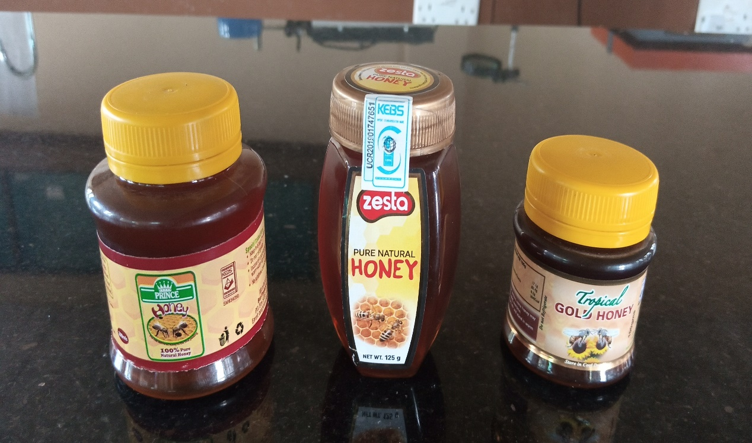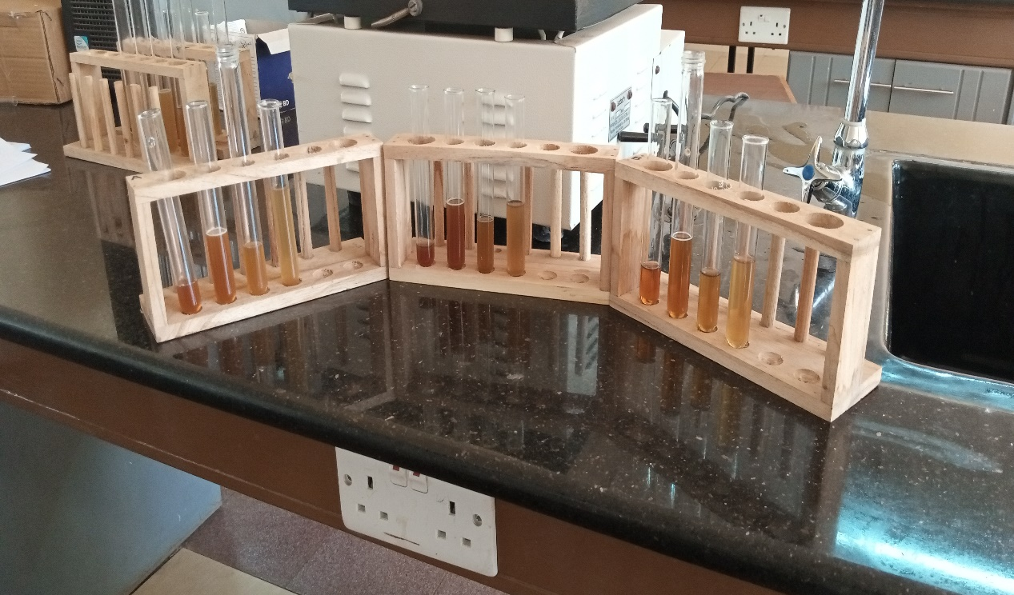
Figure 4: Three honey sample and their dilutions

B. sabtillis.

Figure 5: Zones of inhibition of branded honey samples against gram positive bacteria.

A.baumannii S.enteritidis
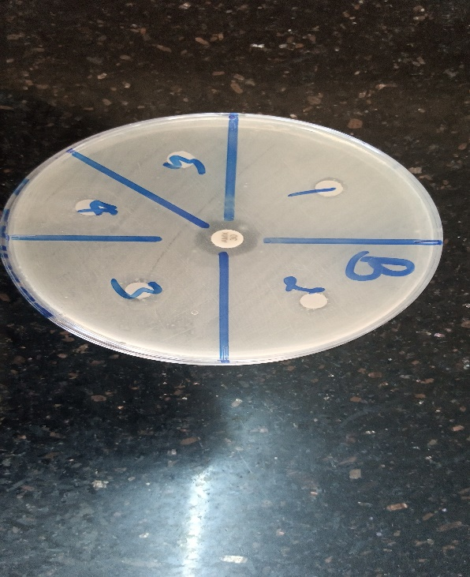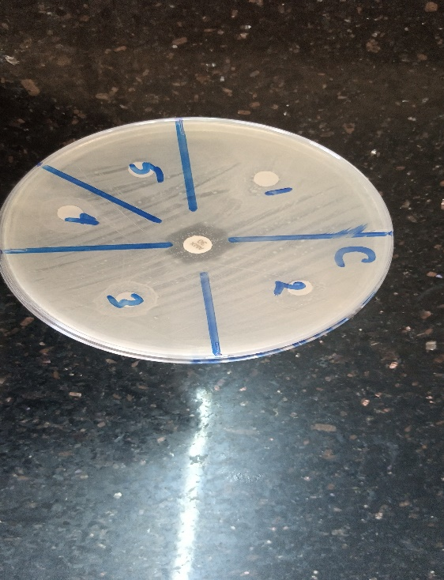
Figure 6: Zones of inhibition of branded honey samples against gram negative bacteria.

